How to set up Eclipse to compile RepRapFirmware

- Install the latest Arduino IDE (1.6.4+) and Eclipse (Luna)

- Start „Arduino IDE“, go to „File → Preferences“ and set content of the text box „Additional Boards Manager URL“ to:
https://github.com/chrishamm/RepRapFirmware/raw/dev/Hardware/package_reprap_index.json

- Confirm your changes by clicking on „OK“ and go to „Tools → Board: … → Boards Manager“. Once you're there, you need to install two board packages:

1) Arduino SAM boards (32-bits, ARM Cortex-M3)
2) Duet platform

- If you haven't done so already, download a copy of the latest RepRapFirmware and unpack it

- Copy „RepRapFirmware.cpp“ and „RepRapFirmware.h“ to a temporary location, you will need them later on

- Open Eclipse and create a new workspace

- Install the Arduino Eclipse Plugin

a) Go to „Help → Install New Software“

b) Add a new repository „Arduino Eclipse Plugin (Nightly)“ with this URL:
http://eclipse.baeyens.it/nightly

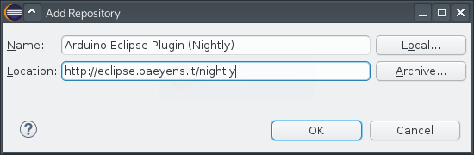

c) Untick „Group Items“ and check „Arduino eclipse extensions“ in the list:

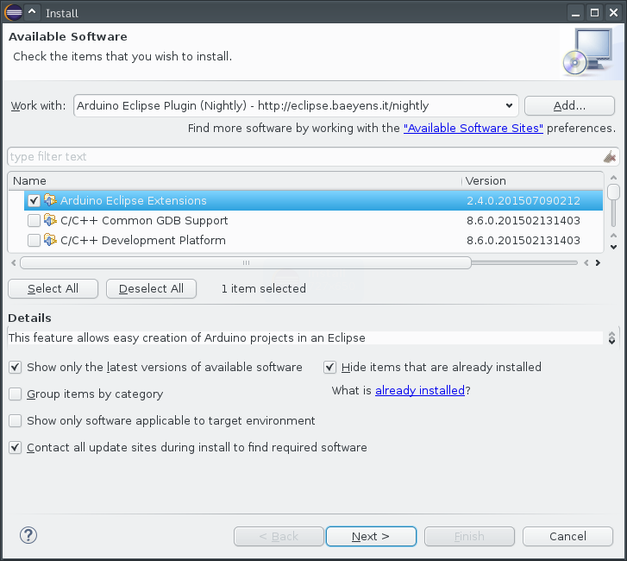

d) Finish the wizard

e) When asked to trust an unknown certificate, select it from the list and
confirm this exception by clicking on „OK“

e) Restart Eclipse

- Create a new Arduino sketch:

a) Go to „File → New → Project“ and select „Arduino → New Arduino
sketch“

b) Call it „RepRapFirmware“ and set the location to the directory of your
RepRapFirmware copy

c) For your „Boards.txt file“ you need to select the one having „RepRap“ in
its file path. On Linux, it will look like this:

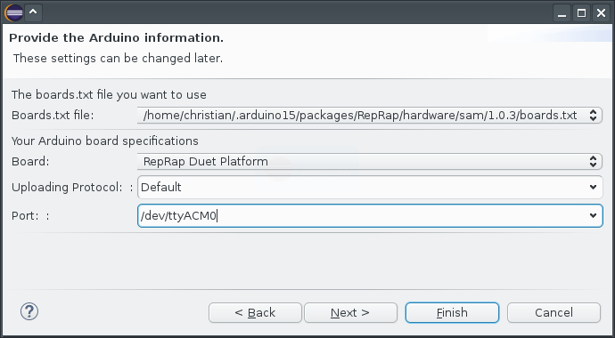

d) Check your source code directory for the following files or directories:

- .cproject
- .project
- .settings
- arduino

If any of them is present, it is highly recommended to delete them before
you continue

e) Finish this wizard

- Overwrite „RepRapFirmware.cpp“ and „RepRapFirmware.h“ with the two files that you backed up earlier

- Right click on „Hardware“ and go to „Resource Configurations → Exclude from build“. Then click on „Select all“ confirm your input

- Right-click on the „RepRapFirmware“ directory in the Project Explorer and go to „Properties → C/C++ General → Paths and Symbols“

- There you must to add four include directories as seen in the following screenshot. On Windows, the Arduino packages directory can be found in %APPDATA%\Arduino15 and on OS X, it is $HOME/Library/Arduino15.

Make sure you have „Add to all languages“ checked while adding them!
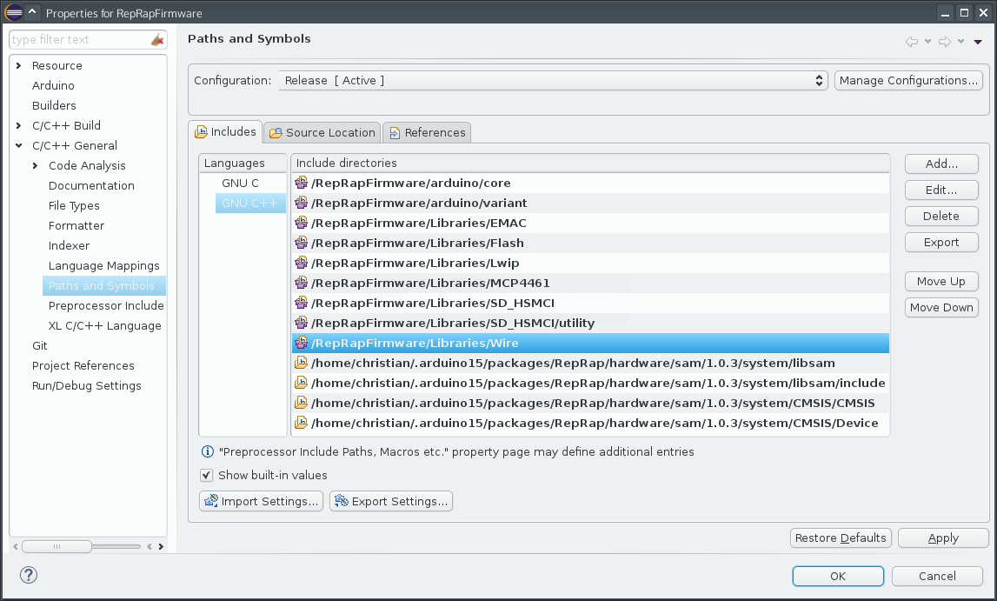

- Press „OK“ and confirm the message prompt asking you to rebuild the search cache

- Select an arbitrary file in the Project Explorer and click on „Verify“ () in the Arduino toolbar to build the firmware. Once everything has been compiled, you can find a new firmware binary in the Release directory

NOTE: Please be aware that this guide advises the use of nightly Arduino Eclipse Plugin builds, because no stable version for Arduino 1.6.4+ was available at the time of writing. For that reason you may see more error/warning messages than you would if you were using only the supplied Makefile.

** Your mileage may vary !

